YHT is having
Jamie Mills-Price
Acrylic Class
September 18, 2021 ll:00AM EST to 6:PM
Via Zoom
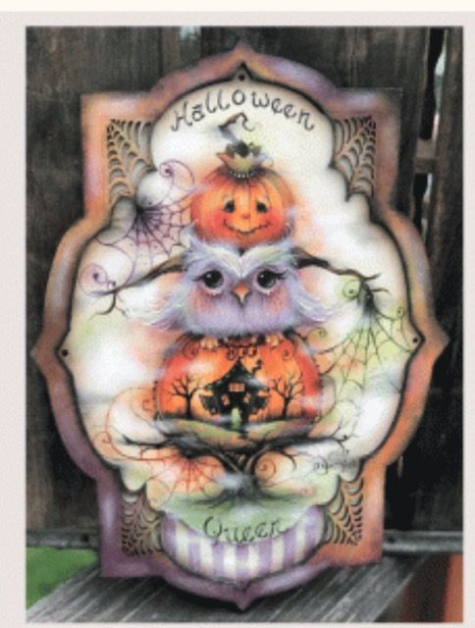
Jamie will be teaching Halloween Queen on September 18. It is a great way to paint with a wonderful teacher. The wood is available at pinecraftinc.com. The sign measures 8.25 x 12. You can also use any surface you have or order it from Pine Craft, Inc. Paints are not included.
The price of the class is $40. for members and $50 for non members. Please sign up as soon as possible. There are a limited amount of spaces.
_____________________________________________________________________________________________
I am enclosing $40 member price_____________
I am enclosing $50 guest price______________
If you have any questions, please contact Barbara Rolla at brolla1@comcast.net or 413-967-5444.
Name______________________________________________________phone#________________________
Address____________________________________________________email_________________________
Please return form and a check made payable to YHT to:

Barbara Rolla
4 Woodland Heights
Ware, MA 01082

