Yankee Heritage Tole Chapter
Presents
A Ros Stallcup hydrangea design
Taught with permission by
Janice Cormier
VIA ZOOM
Sun. August 15, 2021
1:00 to 5:00
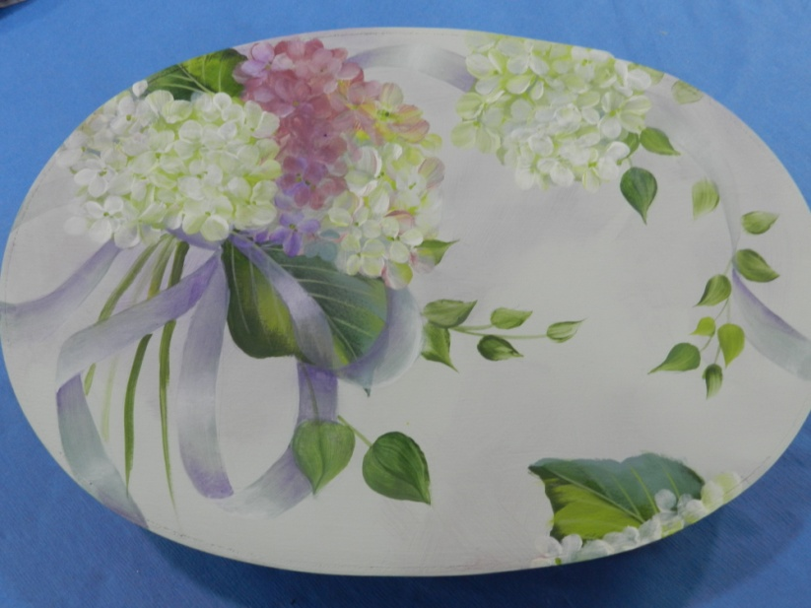
Please join us to paint this wonderful design taught by Janice Cormier. It is painted on a 10inch oval bentwood box, but you can choose to do it on any surface you wish.
Such a great way to spend a Sunday afternoon. Invite your friends to join you. You do not have to be
a member to do this class.
Janice has painted with Ros several times and has had her to her studio to teach classes.
I will send out the prep instructions in July so that you will be ready for the class.

___________________________________________________________________________________

I would like to paint this project. Cost is $25. per person. Please make check payable to YHT and mail to:
Barbara Rolla
4 Woodland Heights
Ware, MA 01082

Name_______________________________________________________

Email________________________________________________________

Price of class $25.__________________________

If you have any questions, please email me at brolla1@comcast.net

